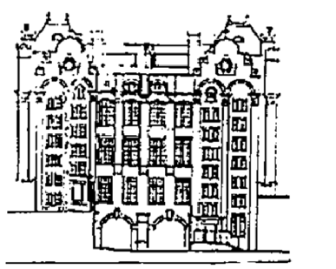
Data Protection – our Privacy Notice

Dear Parents & Carers
We are writing to inform you of our updated data protection policy and privacy notice to fall in line with the new General Data Protection Regulation.
We need to hold personal information about your child both in electronic and paper form to help us with their educational needs. The school is responsible for their accuracy and safekeeping. We collect and use pupil information to comply with regulations such as the Education Acts, the Children’s Act 2004 and the General Data Protection Regulation.
Whilst the majority of information you provide to us on your child is mandatory, some of it is provided to us on a voluntary basis. In order to comply with the General Data Protection Regulation, we will inform you whether you are required to provide certain information to us or if you have a choice in this.
School staff have access to your child’s records to enable them to do their jobs and information may be shared with others involved in your child’s care, if it is necessary. Anyone with access to your child’s records is properly trained in confidentiality issues and is governed by a legal duty to keep their details secure, accurate and up to date. All information about your child is held securely and appropriate safeguards are in place to prevent accidental loss.
The categories of your child’s information that we collect, hold and share include personal information such as their name, their unique pupil number, address and parental contact details. Also educational records such as assessments, results and any Special Educational Needs (SEN) the child may have and measures in place to assist them.
We hold pupil data for as short a time as possible that is consistent with our statutory and legal obligations. We use the Information and Record Management Society’s Toolkit for Schools to inform our decisions on retention period. This means that we will not hold your child’s records for longer than we need to.
We do not share information about our pupils with anyone without consent unless the law and our policies allow us to do so. The law allows us to share data with third parties such as the London Borough of Camden and where they are carrying out duties for the school and appropriate controls are in place.
We also collect information about parents to meet our legal duties and reasons such as to support learning and keep your child safe. Typically, this data includes information such as contact details including e-mail, telephone number and address. We also collect information held in relation to the school’s statutory responsibilities, including in respect of safeguarding and child protection, equalities, health and safety and special educational needs
Under data protection legislation, parents and pupils have the right to request access to information about them that we hold. To make a request for your personal information, or be given access to your child’s educational record please contact us.

